How to install Sacred NL using Web downloader (version 18)

Menu:

1) Where to download Web downloader

2) Installation procedure
2.1) Welcome window
2.2) Installation path selection window
2.3) Selection window for elements to install
2.4) Installation window
2.5) Installation completion window
2.6) End window

3) Installing sound modules

4) What files and where does Web downloader install

5) Uninstall

1) You can download Web downloader from the links (size 184 Kb):
http://www.sacred-nl.necropol.sumy.ua/html/download/SacredNL/loaderNL.exe
or
in chapter «Sacred NL — Web downloader»
http://www.sacred-nl.necropol.sumy.ua/html/download/download.php
https://drive.google.com/file/d/1RexPqaml9yZS99vszXAdYTdwOnfDKSzY/view?usp=sharing

2) Installation procedure
2.1) By running the installer, we will see the welcome window.
You will need to choose your original Sacred installation folder:
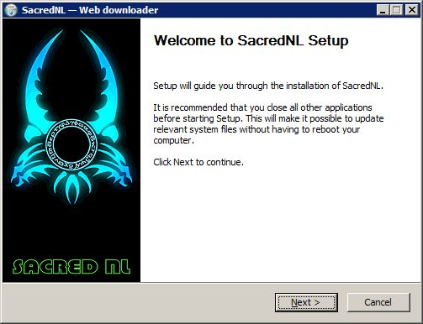

2.2) Pressing Next, go to the window for selecting the installation path:
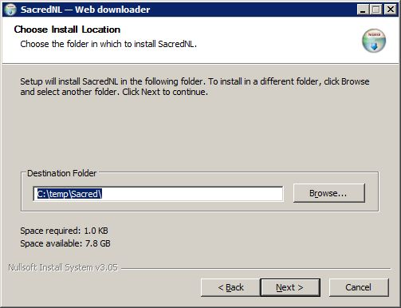

Note. After choosing the installation path, it is remembered in the registry branch
HKEY_LOCAL_MACHINE\SOFTWARE\SacredNL in INSTDIR parameter.
This saved path will be used on subsequent installations.

2.3) Clicking Next, go to the window for selecting items to install:
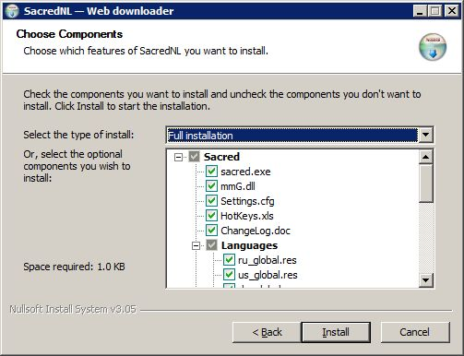
There are five types of installation:
Full installation — initial full installation,
mmG.dll new version — install only modified files,
Language modules — selection of text modules,
Sound modules — selection of sound modules *,
Custom — free choice of elements for installation.
* Since the sound modules (due to insufficient space for the "Sacred NL" site)
are placed on Google Drive, the SoundModules_ReadMe.txt file is written to the PAK\snd folder instead of them, with information about the location of sound modules files (see p. 3 — Installing sound modules).

2.4) Pressing Install, we will go directly to the installation window:
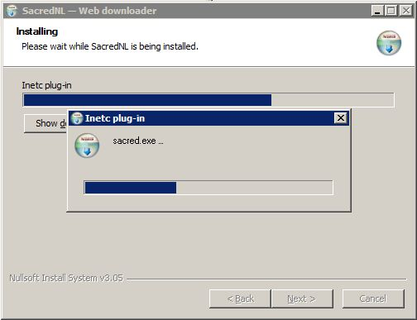

Note. The picture shows the process of loading the main game file.

2.5) After successfully downloading and installing the selected items, the installation completion window will appear:
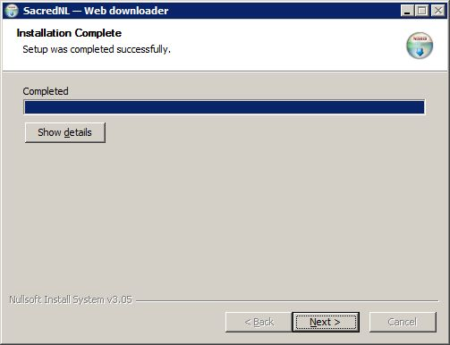

2.6) Clicking Next, go to the final window:
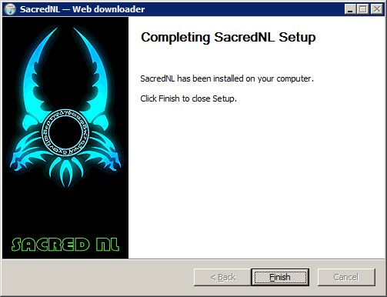

3) Installing sound modules
a) As already mentioned, sound modules (due to insufficient space for the "Sacred NL" site)
are hosted on Google Drive. Instead, during installation, the SoundModules_ReadMe.txt file is written to the PAK\snd folder with information about the location of the sound module files.
b) If there is no provision for a dynamic selection of sound modules, then they can be omitted.
This will use the existing PAK\sound.pak file.
c) The necessary sound modules are downloaded from the links:
http://www.sacred-nl.necropol.sumy.ua/html/download/download.php (select in the corresponding lines of the table)
or
https://drive.google.com/drive/folders/1BAJw7LbrpF1XFfFbi4h0a2X4QQfcd4PM
d) The downloaded sound modules must be copied to the PAK\snd folder.

4) What files and where does the Web downloader install to?
a) The following files are copied to the game folder: settingsNL.cfg, mmG.dll, gameserverNL.exe, sacredNL.exe, configNL.exe, Uninstall.exe, dsound.dll, dsound.ini.
b) For the files ChangeLog.doc, ChangeLog_eng.doc, HotKeys.xls and settings_cfg.xls, a special folder called info is created, into which these files are installed.
c) The selected text modules (NN_global.res) are copied to the scripts folder.
d) The PAK\snd folder is created in which the SoundModules_ReadMe.txt file is written
(see p. 3).
e) The file LoadingNL01.bmp is written into the PAK folder.
f) In the ..\World folder the file MouseOver.bin, repNL.bin, keyboard.kbd, sct.bin.

5) Uninstall
It is carried out by running the Uninstall.exe file from the game folder.
