1) Customize User Defined Keywords color

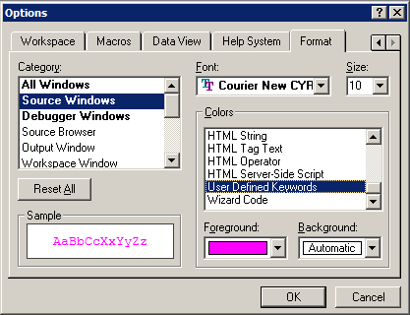

2) Path to USERTYPE.DAT

c:\Program Files\Microsoft Visual Studio\Common\MSDev98\Bin\USERTYPE.DAT

